**Topics: Normal distribution, Functions of Random Variables**

1. The time required for servicing transmissions is normally distributed with *μ* = 45 minutes and *σ* = 8 minutes. The service manager plans to have work begin on the transmission of a customer’s car 10 minutes after the car is dropped off and the customer is told that the car will be ready within 1 hour from drop-off. What is the probability that the service manager cannot meet his commitment?
2. 0.3875
3. 0.2676
4. 0.5
5. 0.6987

Given : x= 60, *μ* =45+10 =55 ,*σ* = 8

So from Python we can calculate probability = **0.2676**

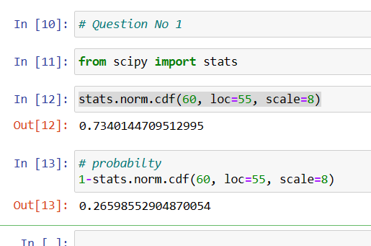

1. The current age (in years) of 400 clerical employees at an insurance claims processing center is normally distributed with mean *μ* = 38 and Standard deviation *σ* =6. For each statement below, please specify True/False. If false, briefly explain why.
2. More employees at the processing center are older than 44 than between 38 and 44.
3. A training program for employees under the age of 30 at the center would be expected to attract about 36 employees.

Given : *μ* = 38 *σ* =6 , X= 44, 38,30

So we calculate Z score by Formula =(X-*μ)* / *σ*

**A.**

For 44 Z- Score = (44-38)/6 = 0.8413

For above 44 = 1-0.8413 = 0.1587

Employees Over 44 = 0.1587 * 400 = 63

For 38 Z- Score = (38-38)/6 = 0.5

For Between 38 and 44 = 0.8413 – 0.5 = 0.3413

Employees Between 38 and 44 = 0.3413 * 400 = 136

**From above values Statement A is False**

**B.**

For 30 Z- Score = (30-38)/6 = 0.09176

Employees Below 30 = 0.09176 * 400 = 36

**So Statement B is True.**

1. If *X1* ~ *N*(μ, σ2) and *X*2 ~ *N*(μ, σ2) are *iid* normal random variables, then what is the difference between 2 *X*1 and *X*1 + *X*2? Discuss both their distributions and parameters.

**Answer :** 2 $X_{1}$ is simply a larger scale version of the random variable X1. If $X_{1}$ is normally distributed then 2X1 is also normally distributed.

X1 and X2 are normal distributed, the associated sums and random samples are exactly (and not just approximately) normal, with the appropriate parameters.

1. Let X ~ N(100, 202). Find two values, *a* and *b*, symmetric about the mean, such that the probability of the random variable taking a value between them is 0.99.
2. 90.5, 105.9
3. 80.2, 119.8
4. 22, 78
5. 48.5, 151.5
6. 90.1, 109.9

Given : Here P(a<X<b)=0.99 mean = 100 & Std. Dev= 20

For Z-score 100 -0.99 = 0.01

This 0.01 is symmetric about mean so we have to find Z- Scores of 0.005 & 0.995

From python we get Z(0.005) = -2.57 & Z(0.995) = 2.57

So from formula Z=(X- μ)/ σ

-2.57=(a-100)/20 **a= 48.5**

& 2.57=(b-100)/20 **b= 151.5**

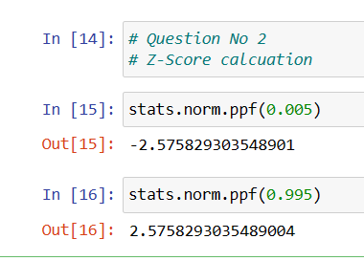

1. Consider a company that has two different divisions. The annual profits from the two divisions are independent and have distributions Profit1 ~ N(5, 32) and Profit2 ~ N(7, 42) respectively. Both the profits are in $ Million. Answer the following questions about the total profit of the company in Rupees. Assume that $1 = Rs. 45
2. Specify a Rupee range (centered on the mean) such that it contains 95% probability for the annual profit of the company.

**Answer**- From the empirical rule, Approximately 95% of the data falls within two standard deviation of the mean.

μ ± 2σ = 540±2*225=> (540-450, 540+450)=>**(90,990)**

1. Specify the 5th percentile of profit (in Rupees) for the company

**Answer-** for 5th percentile

formula X= X=μ + Zσ

from z table 5 percentile = -1.645

X = 540+(-1.645)*225

X = 169.875

1. Which of the two divisions has a larger probability of making a loss in a given year?

**Answer-** this question concerns the original profit distributions.

For division1= Z score for a profit of zero: Z=(X-µ)/σ => (0-5)/3 => -1.66=0.0485

stats.norm.cdf(0, loc =5, scale = 3 ) =0.04779035

For division2= Z score for a profit of zero: Z=(X-µ)/σ =(0-7)/4 => -1.75= .0401

stats.norm.cdf(0, loc =7, scale = 4 ) = 0.04005916

**Division2 has a higher probability of making a loss.**

